Sprint 1 Progress Report

Isaac Pittolo – 7695438  
Hoang Linh Bui – 100017631  
Adam Bubonya - 9986677

# Sprint Meeting 1 Progress – 01/04/16

Meeting Minutes

Date/Time: 1/04/16 @ 9:40pm

Duration: 7 minutes

Location: Facebook Voice Chat

Members in attendance:

IP, AB, HB

Decisions

* Development Environment we will be using is Visual Studio.
* Framework to be created first
* Inventory In/Out to be developed on first
* AB/IP unable to commence work. HB to start framework.

Actions

1-APR, HB, Commence work on Inv In/Out Functions

Meeting Concluded

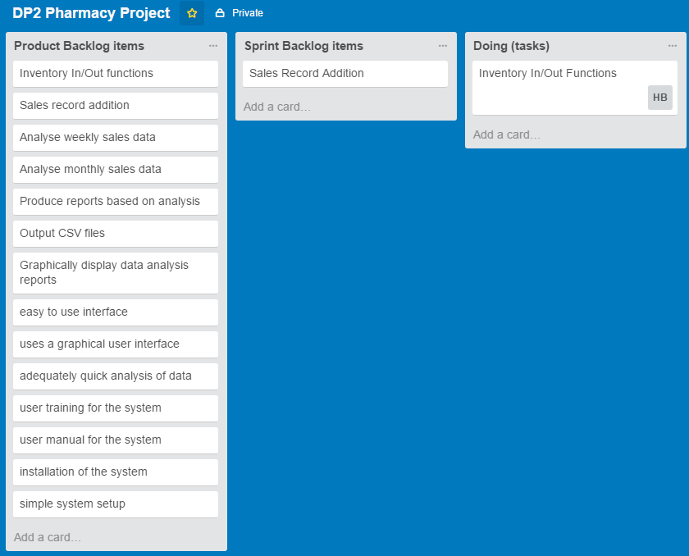

In this meeting our group met up and decided on who was to do what. Due to time constraints only Hoang could work on the task today, with plans on further implementation at the next meeting.

Sprint Meeting 2 Progress – 04/04/16

Meeting Minutes

Date/Time: 4/04/16 @ 9:00pm

Duration: 5 minutes

Location: Facebook Voice Chat

Members in attendance:

AB, HB

Decisions

* Prepare handover of sales record backlog item for IP
* Continue with work on Inv In/Out functions

Actions

4-APR, HB, Continue work on Inv In/Out Functions

5-APR, AB, Prepare scope for IP in Sales Record Functions

Meeting Concluded

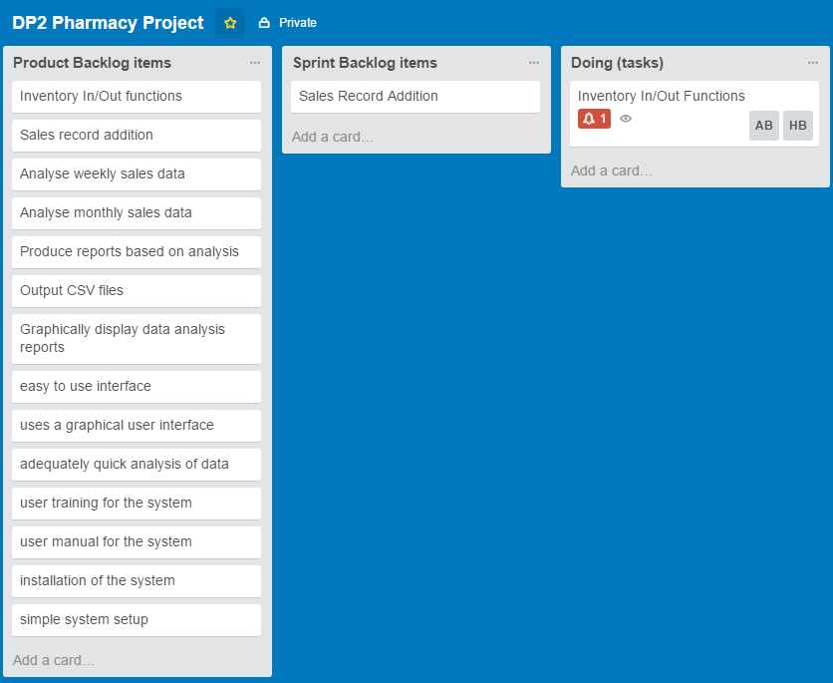

Isaac was unavailable for this meeting and could not be assigned to any tasks. Huang and Adam proceeded to work on the Inventory In/Out Functions for the day.

# Sprint Meeting 3 Progress – 05/04/16

Meeting Minutes

Date/Time: 5/04/16 @ 10:30am

Duration: 11 minutes

Location: Facebook Voice Chat

Members in attendance:

IP, AB, HB

Decisions

* IP assigned Sales Record Addition
* AB to assist HB

Actions

6-APR, HB/AB, Continue with Inv In/Out Funct.

5-APR, IP, Commence Sales Record Additions

Meeting Concluded

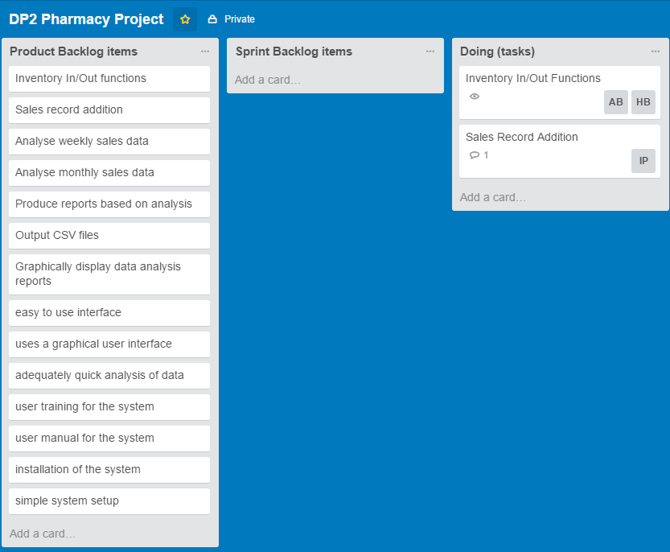

Isaac, Adam and Huang met up today and discussed progress on the Inventory In/Out functions as well as Isaac’s large contribution made in the Sales Record Addition.

Sprint Meeting 4 Progress – 06/04/16

Meeting Minutes

Date/Time: 6/04/16 @ 9:00pm

Duration: 4 minutes

Location: Facebook Voice Chat

Members in attendance:

IP, AB, HB

Decisions

* Sales Record deemed suitable for testing
* Inv In/Out needs more work before testing

Actions

12-APR, HB/AB, Complete work on Inv In/Out

Meeting Concluded

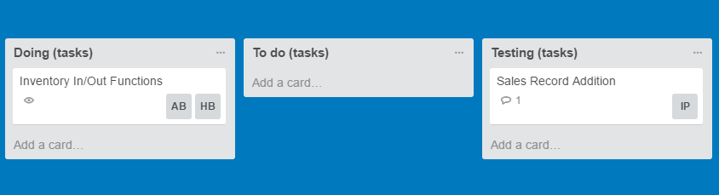

Isaac spent a considerable amount of time working on additions to the Sales Records. After having a working system the group has decided to move the task from Doing to Testing.

Huang and Adam continued with their progress on the Inventory In/Out Functionality.

# Sprint Meeting 5 Progress – 07/04/16

Meeting Minutes

Date/Time: 7/04/16 @ 10:00pm

Duration: 5 minutes

Location: Facebook

Members in attendance:

IP, AB, HB

Decisions

* IP to continue to test.
* AB to look into GUI issues

Actions

7-APR, IP, Continue testing

7-APR, AB, Resolve GUI issues.

Meeting Concluded

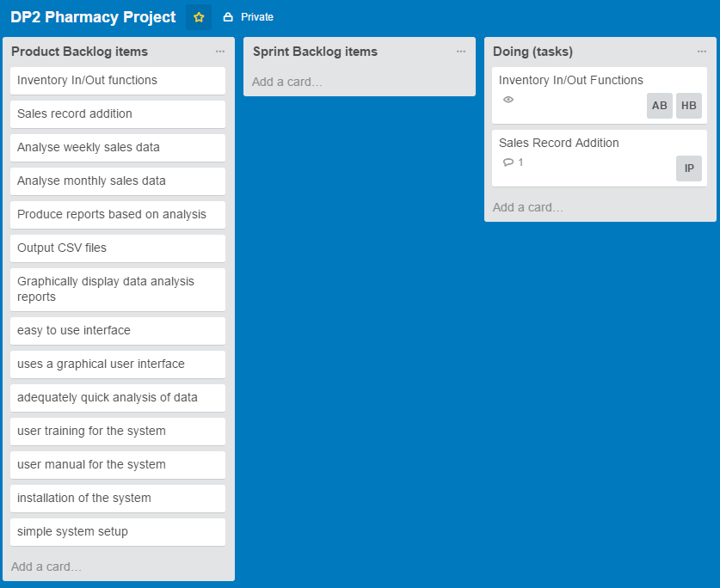

Unfortunately during testing our group discovered that the Sales Record Additions were quite difficult to implement into our total project. Therefore, the task was moved back into our Doing category.

# Burndown Chart

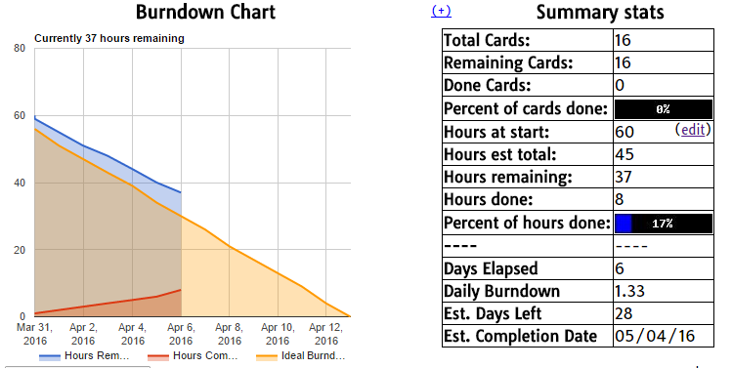

We were not able to record our Burndown chart on a day-by-day basis. However, this is the burndown chart as of the end of this week, which demonstrates our progress made during this sprint.

# Repository Changes for the Week

